CrowdStrike Falcon EDR Validation – Test Execution Report
Step-by-Step Record of the Procedure Performed

Objective: Validate CrowdStrike Falcon sensor detection on a Windows VM using an EICAR test file, followed by PowerShell-based .exe execution tests
Test Environment: Oracle VirtualBox – Windows 10 VM (host: WIN10), user: vboxuser; secondary VM "leviathan" used for PowerShell execution tests
Date Performed: September 23–24, 2026
Team Members Involved: Nomuls Snehith, Gunnala Kavya, Benduri Akshaya

Team Members
Team Member | Role
Nomuls Snehith | Security Engineer – EDR Testing
Gunnala Kavya | Security Engineer – EDR Testing
Benduri Akshaya | Security Engineer – EDR Testing

Step 1 – Install the CrowdStrike Falcon Sensor on the Windows VM
What we did: Downloaded the FalconSensor_Windows installer to the desktop of the Windows 10 test VM (Oracle VirtualBox) and confirmed the installer package (128,653 KB) was present and ready to run.
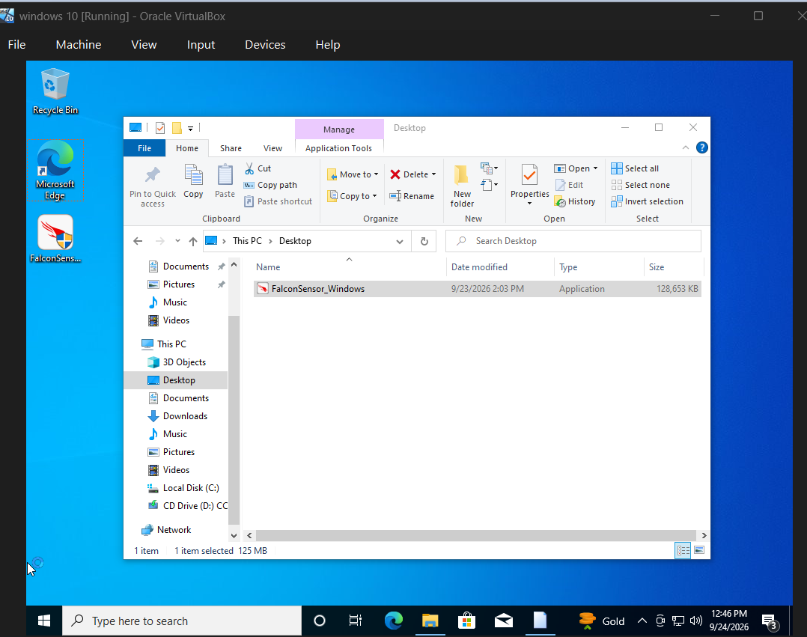
Figure 1 – FalconSensor_Windows installer staged on the Windows 10 VM desktop.
What we did next: Opened the Falcon console's Sensor Downloads page, copied the Customer ID (CID) required for installation, and ran the CrowdStrike Falcon Sensor Setup on the VM. The installer initialized and completed the deployment.
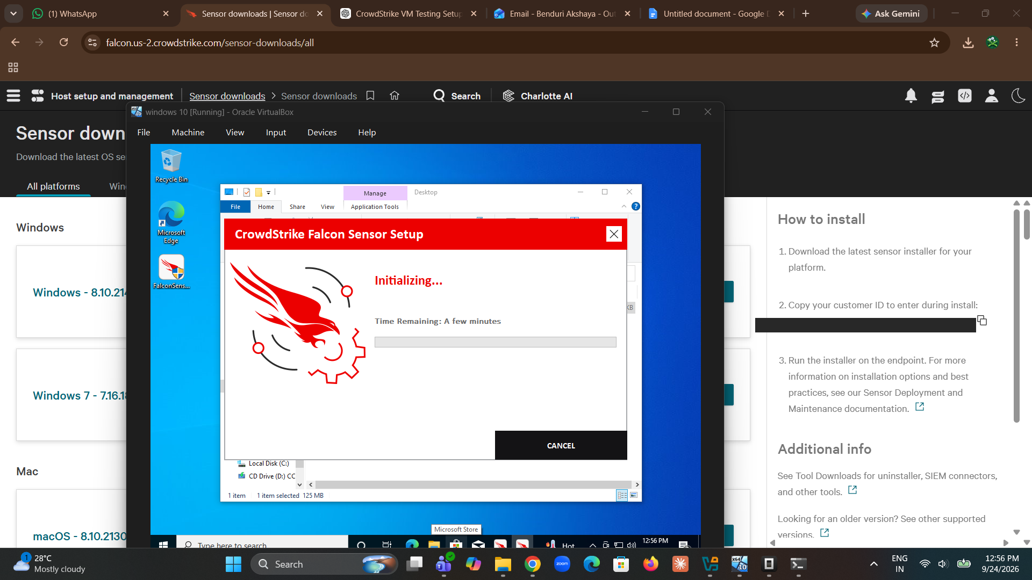
Figure 2 – CrowdStrike Falcon Sensor Setup initializing on the Windows 10 VM (CID redacted for security).
Result: The Falcon sensor installed successfully and the host (WIN10) registered as an active sensor in the Falcon console, running sensor version 7.40.21309.0.

Step 2 – Download the EICAR Test File
What we did: On the same Windows VM, navigated to the official EICAR test file page (eicar.org/download-anti-malware-testfile) and attempted to download eicar_com.zip to trigger the sensor's file-write inspection.
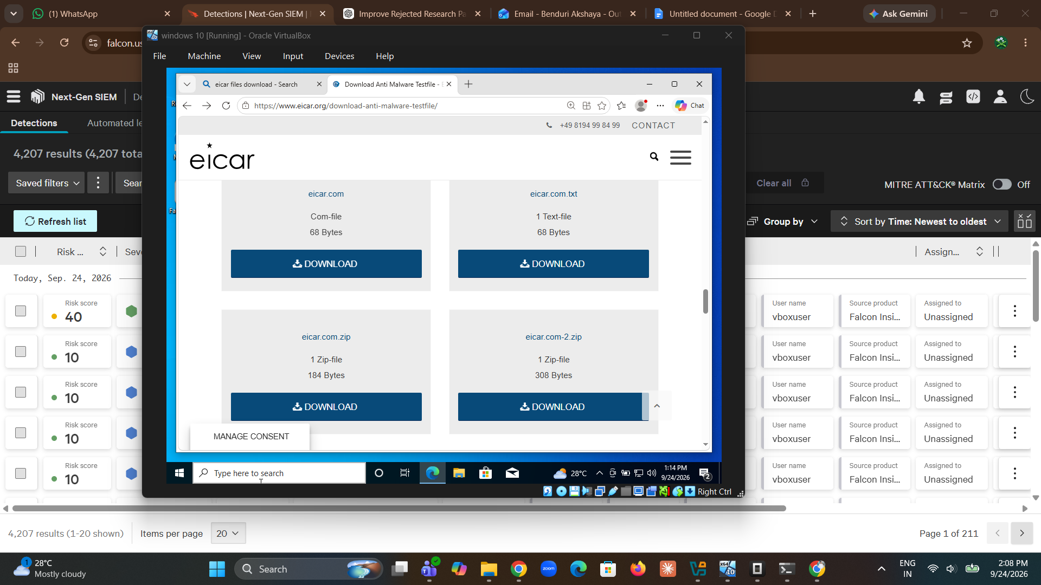
Figure 3 – EICAR anti-malware test file download page opened in the VM's browser.
First attempt: The first download attempt of eicar_com.zip was blocked by Microsoft Edge's built-in download protection, which flagged the file as unsafe (expected, since EICAR is designed to be flagged by security tools).
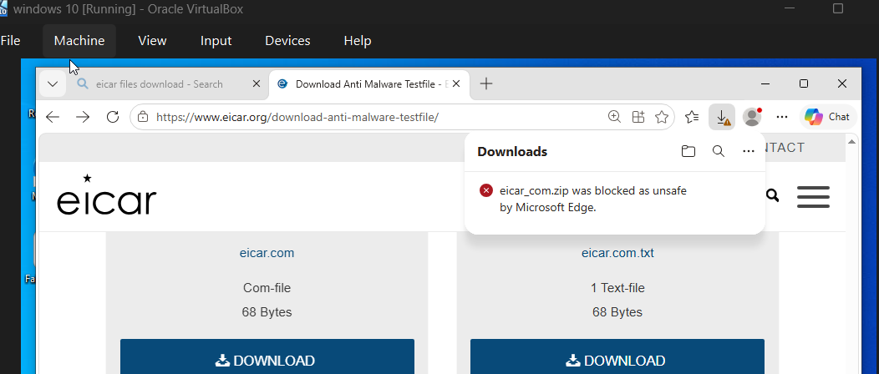
Figure 4 – Microsoft Edge blocked the first eicar_com.zip download as unsafe.
Second attempt: Retried the download; eicar_com.zip (184 bytes) completed successfully to the VM, allowing the file to be written to disk for Falcon sensor inspection.
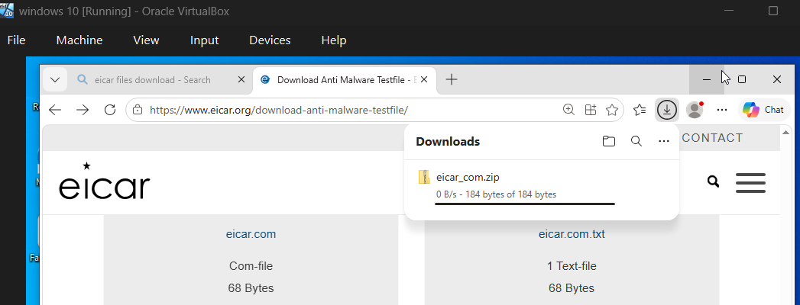
Figure 5 – eicar_com.zip successfully downloaded (184 bytes) on the second attempt.

Step 3 – Verify EICAR Detection in the Falcon Console
What we did: Logged in to the CrowdStrike Falcon console and reviewed the Detections dashboard for the WIN10 host to confirm whether the EICAR file write was detected.
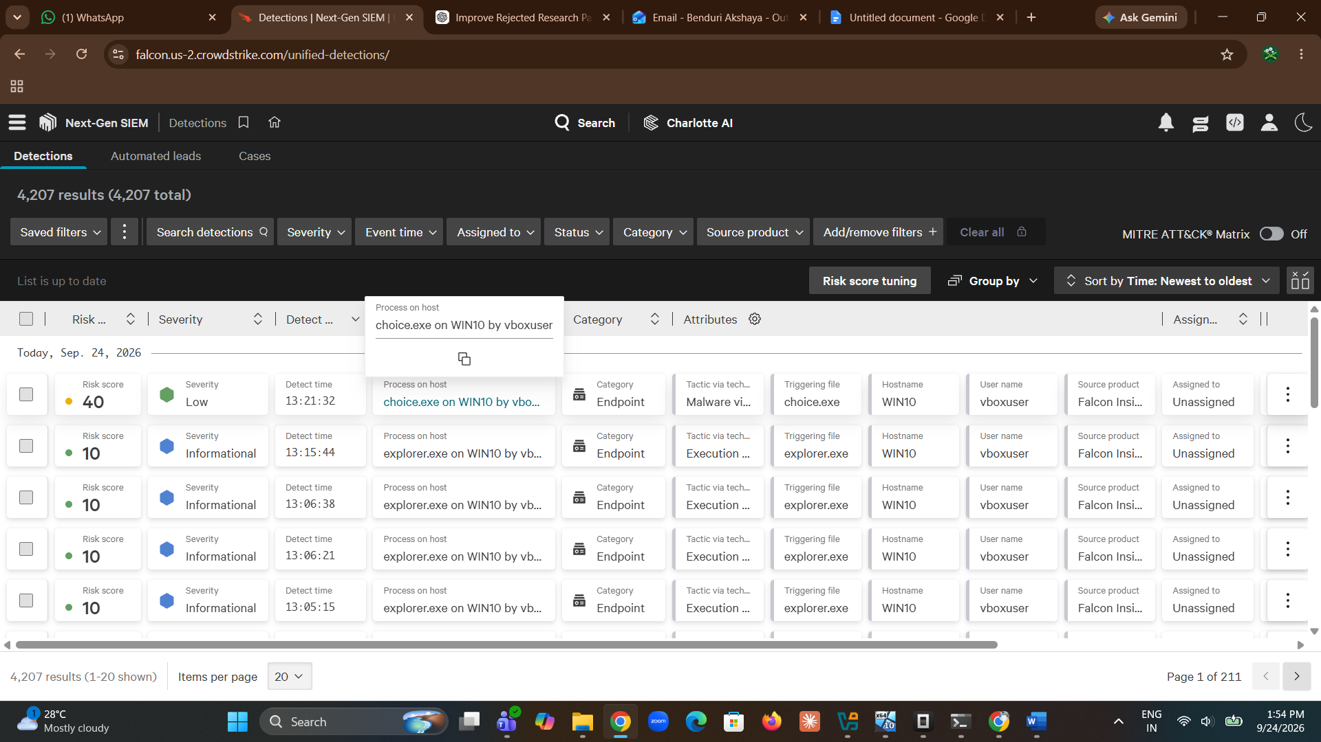
Figure 6 – Falcon Detections dashboard showing activity on host WIN10, including a malware-related detection on choice.exe.
Detection confirmed: A detection fired with the description "A process has written a known EICAR test file. Review the files written by the triggered process," triggered via explorer.exe on WIN10 under user vboxuser.
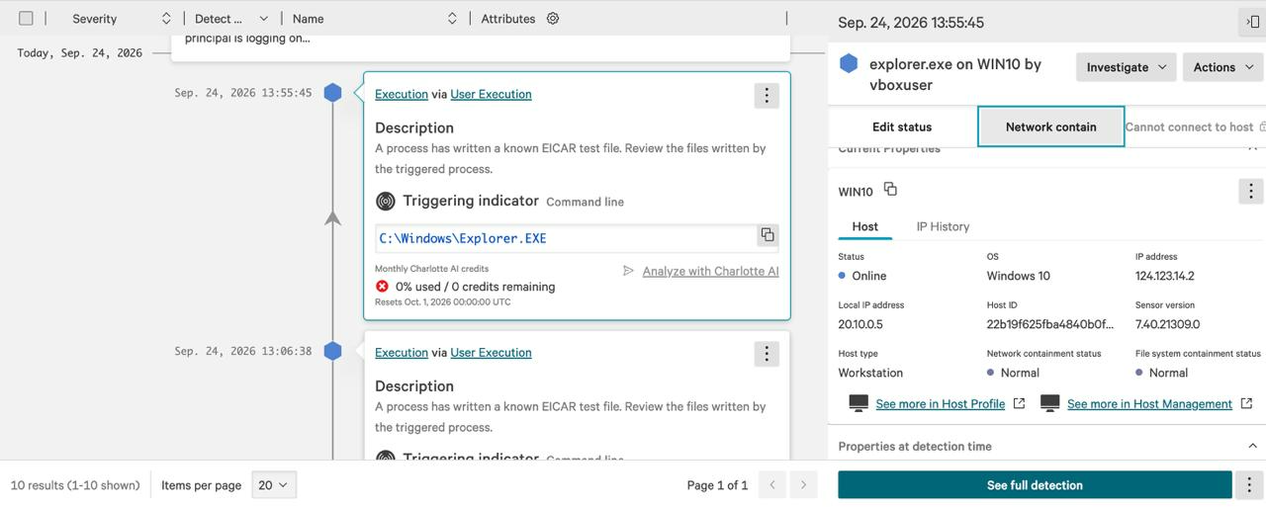
Figure 7 – Falcon detection detail: EICAR test file write detected via explorer.exe on WIN10.
Full detection details reviewed: Opened the full detection to confirm: Severity = Informational, Tactic & Technique = Execution via User Execution (T1204), IOA name = EICARTestFileWritten, Command line = C:\Windows\Explorer.EXE, Actions taken = None (logged/alerted, no automated remediation).
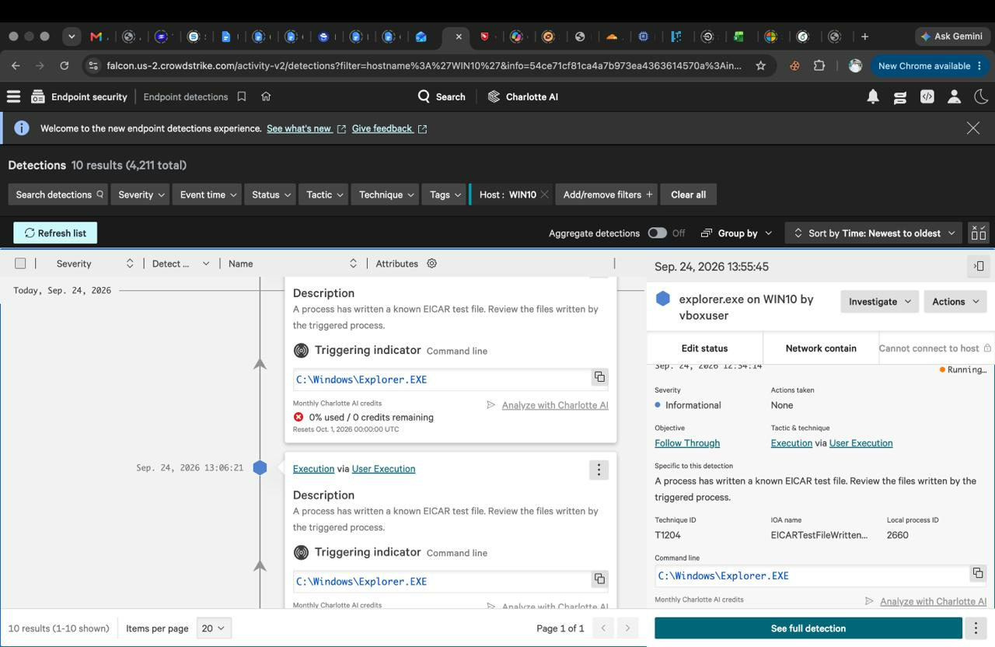
Figure 8 – Full EICAR detection details in the Falcon console (severity, technique ID, IOA name, command line).
Result: EICAR detection was successfully generated and reflected in the Falcon console, confirming the sensor correctly inspects file-write activity.

Step 4 – Perform Controlled PowerShell-Based .exe Execution Tests
What we did: After confirming EICAR detection, moved to a second VM ("leviathan") and opened Windows PowerShell to run controlled, benign executable launches to observe Falcon's behavior against PowerShell-initiated process execution.
Commands executed: Start-Process calc.exe (run multiple times) and start-process 'C:\Windows\System32\notepad.exe'.
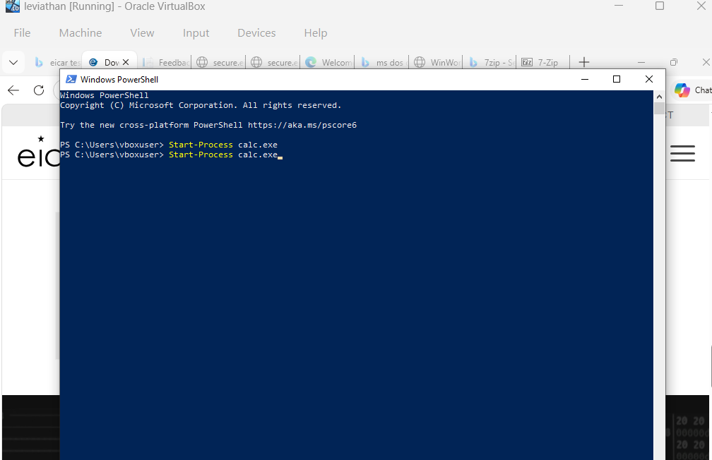
Figure 9 – PowerShell session on the test VM running Start-Process calc.exe.
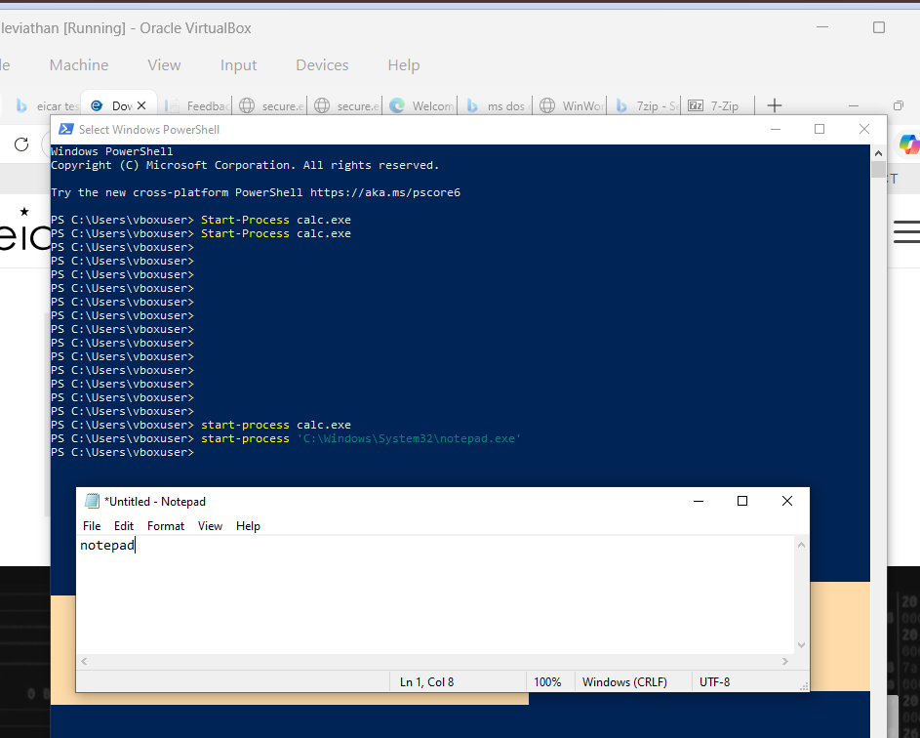
Figure 10 – Extended PowerShell session showing repeated calc.exe launches and a successful notepad.exe launch.
Result: All commands executed successfully on the VM — Calculator and Notepad launched as expected via PowerShell without being blocked.

Step 5 – Monitor and Verify PowerShell Activity in the Falcon Console
What we did: Returned to the Falcon console and opened the Process Tree view for the WIN10 host detection to trace the full parent-child execution chain and check whether the PowerShell/.exe activity generated its own alert.
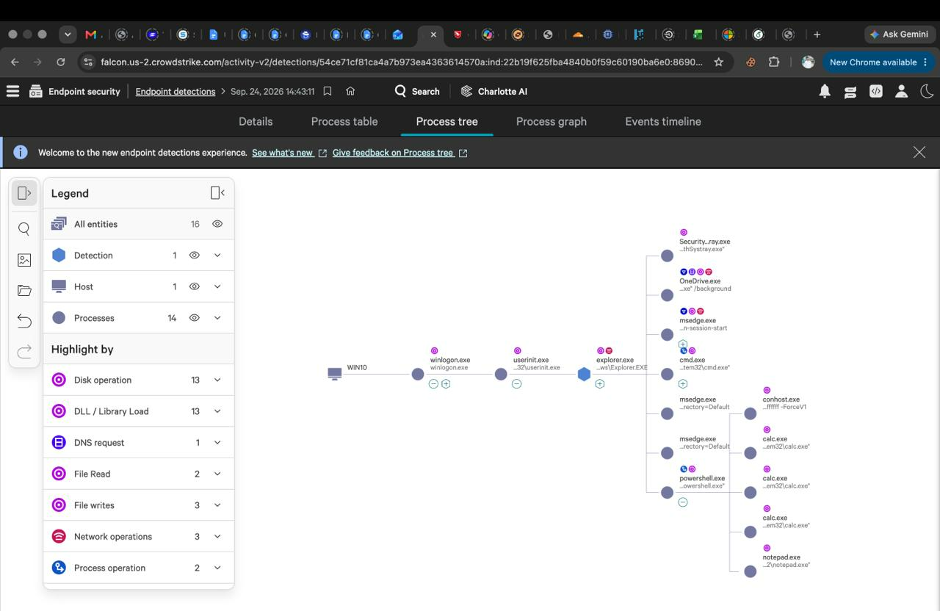
Figure 11 – Falcon Process Tree showing WIN10 → winlogon.exe → userinit.exe → explorer.exe → powershell.exe → calc.exe (x3) / notepad.exe.
Observation: The process tree correctly captured the full execution chain, including PowerShell spawning calc.exe (three instances) and notepad.exe. However, the Legend confirms only 1 detection was recorded for this tree overall — corresponding to the earlier EICAR file-write event. The PowerShell-launched calc.exe/notepad.exe activity was logged as normal process telemetry but did not trigger a separate detection or alert, since launching built-in Windows utilities via PowerShell is common, benign behavior.

Step 6 – Document the Results
Findings from all tests performed were consolidated into the table below for reporting and review.
Test Performed | Detection/Alert Generated | Detection Name / IOA | Severity | Response/Action Taken | Reflected in Falcon Console
EICAR test file download & write (eicar_com.zip via explorer.exe) | Yes – Detection generated | EICARTestFileWritten (Technique T1204 – Execution via User Execution) | Informational | None (logged/alerted only; no automated remediation triggered) | Yes – visible under Endpoint Detections for host WIN10
PowerShell: Start-Process calc.exe (multiple runs) | No separate detection/alert generated | N/A | N/A | None – process allowed to run | Captured as process activity in Process Tree only, not as a standalone detection
PowerShell: start-process 'C:\Windows\System32\notepad.exe' | No separate detection/alert generated | N/A | N/A | None – process allowed to run | Captured as process activity in Process Tree only, not as a standalone detection

Summary of Findings
- The Falcon sensor was installed and registered successfully on the Windows 10 test VM.
- The EICAR test file write was correctly detected and reflected in the Falcon console as an Informational-severity detection (IOA: EICARTestFileWritten, Technique T1204).
- PowerShell-based launches of calc.exe and notepad.exe executed successfully and were captured in the process tree/telemetry, but did not generate a standalone detection — consistent with these being benign, whitelisted Windows utilities rather than malicious activity.
- The full parent-child process chain (explorer.exe → powershell.exe → calc.exe/notepad.exe) was accurately reflected in the Falcon console's Process Tree view, confirming visibility even where no alert was raised.
- Overall, sensor deployment, EICAR detection, and process visibility for PowerShell-initiated execution were all validated successfully on the test host.

Performed and documented by: Nomuls Snehith, Gunnala Kavya, Benduri Akshaya

